

Kocaeli University Mechanical Engineering Dynamics Course

Project Homework-1

(Basic Rocket Dynamics Modelling)

EREN YAYLACI

200217029

In this project, I made the one-dimensional system model of the rocket by computation and tabulation in matlab.

The features of the rocket I used as a base in my project assignment are given below:

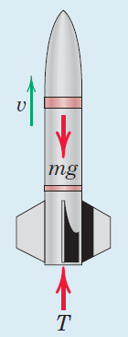

| Rocket Body Weight | 15 kg |
| --- | --- |
| Rocket Fuel Weight | 6 kg |
| Fuel Burn Speed | 2 kg/s |
| Thrust Weight Ratio | 2 |

Values are defined as follows:

Rocket_W = 15; %kg

Fuel_W = 6; %kg

Fuel_Burn = 3; % kg/s

t_W_r = 2; %thrust weight ratio

We can derive the critical value required for the rocket to take off with the following formula.(r = thrust weight ratio)

$G.r = T$

$T = v(e).m' = m.g.r$

$v(e) = m.g.r/m'$

v_e = (g*Sum_W*t_W_r)/Fuel_Burn; % m/s

We find the instantaneous velocity with the following relation.

$v(t) = v(e).ln(\frac{m(0)}{m(t)})-g.t$

v = v_e*(abs(ln(Sum_W/Sum_W*(1-Fuel_Burn*t))))- g*t;%m/s

With this data we have, we can plot the velocity time graph until the fuel runs out.

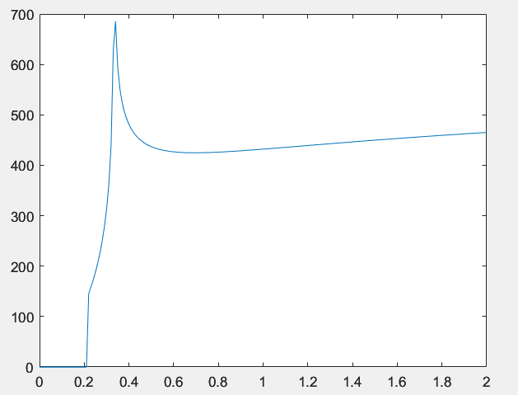

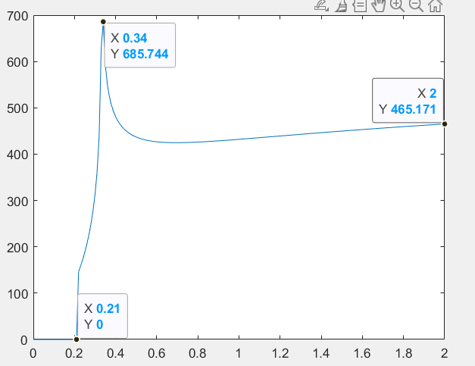

x-axes => time

y-axes => instantaneous velocity

Then I calculated the highest altitude and flight time of the rocket by using the law of conservation of mechanical energy using the speed the rocket achieved at the end of combustion.

| h(max) | 11,8092 km |
| --- | --- |
| flight time | 49,4180 s |

Matlab Code:

Rocket_W = 15; %kg

Fuel_W = 6; %kg

Fuel_Burn = 3; % kg/s

g = 9.81; % m/s^2

Sum_W = Rocket_W + Fuel_W;

time = Fuel_W/Fuel_Burn;%

v_t = ones(time*100,2);

t_W_r = 2; %thrust weight ratio

v_e = (g*Sum_W*t_W_r)/Fuel_Burn; % m/s

S = 0;

s_t = ones(time*100,2);

i = 0;

k =0;

for t = 0:+0.01:time

i = i + 1;

Gravity_Velocity = g*t;

v = v_e*(abs(ln(Sum_W/Sum_W*(1-Fuel_Burn*t))))- Gravity_Velocity;

if v >= v_e && k==0

disp("take off");

disp(i);

disp(v);

k = 1;

else

if k ~= 1

v = 0;

end

end

disp(t);

disp(v);

v_t(i,:) = [t,v];

S = S + v/100;

disp(S)

s_t(i,:) = [t,S/1000];

end

disp(S)

v_s = v_t(time*100+1,2);

K_E = (Rocket_W*(v_s)^2)/2;

P_E = Rocket_W*g*S/1000;

time_s = v_s/g;

F_time = time + time_s;

h = (K_E/(Rocket_W*g)+S)/1000;

plot(v_t(:,1),v_t(:,2));